**Optimizing User, Group, and Role Management with Access Control and Workflows**

Team Id: NM2025TMID18313

Team Members:3

Team Leader: Karishma A

Team Member 1: Keerthana J

Team Member 2: Siva Ranjini R

Team Member 3: Jamuna S

Problem Statement:

Objective:

To streamline and automate IT service management processes using ServiceNow, improving efficiency, reducing response time, and enhancing user satisfaction across the organization.

Skills:

TASK INITIATION

Milestone 1 : Users

**Create Users**

1.Open service now

2.Click on All  >> search for users

3.Select Users under system security

4.Click on new

5.Fill the following details to create a new user

6.Click on submit

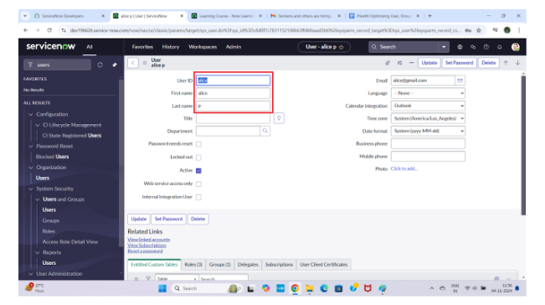

Create one more user:

7. Create another user with the following details

8. Click on submit

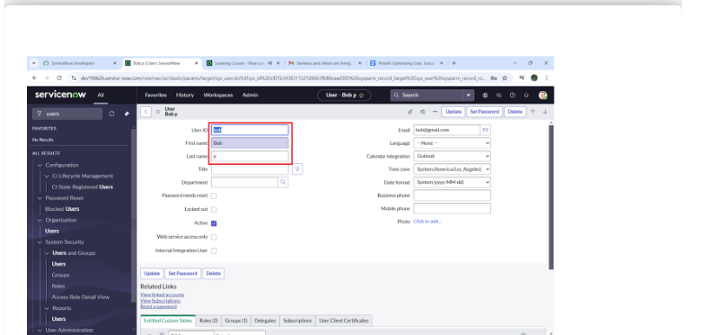

Milestone 2 : Groups

Activity 1: Create Groups

1.Open service now.

2.Click on All  >> search for groups

3.Select groups under system security

4.Click on new

5.Fill the following details to create a new group

6.Click on submit

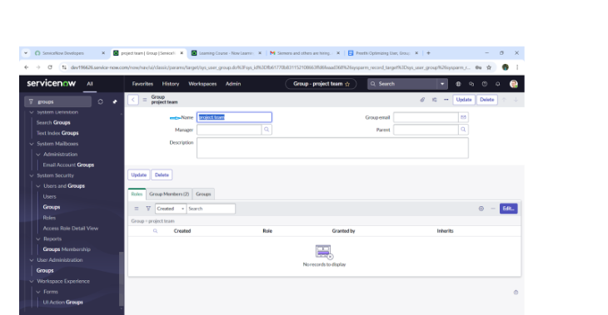

Milestone 3 : Roles

Activity 1: Create roles

1.Open service now.

2.Click on All  >> search for roles

3.Select roles under system security

4.Click on new

5.Fill the following details to create a new role

6.Click on submit

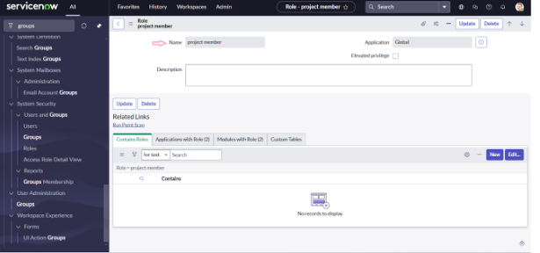

Create one more role:

7.Create another role with the following details : Team member.

 8.Click on submit.

Milestone 4 : Table Activity 1: Create Table

1.Open service now.

2.Click on All  >> search for tables

3.Select tables under system definition

4.Click on new

5.Fill the following details to create a new table  
Label : project table  
Check the boxes Create module & Create mobile module

6.Under new menu name : project table

7.under table columns give the columns

8. Click on submit 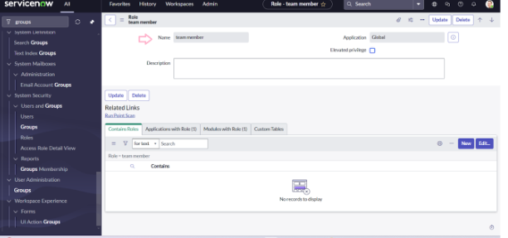  
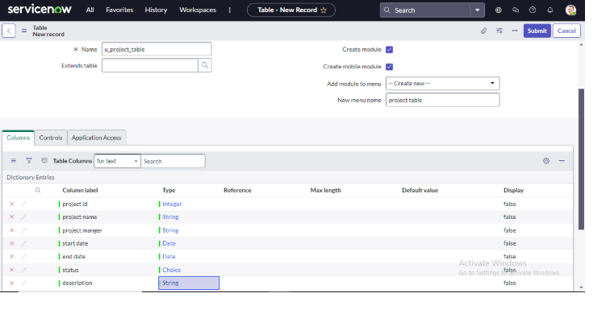

Create one more table:

9.Create another table as: task table 2 and fill with following details.

10. Click on submit.

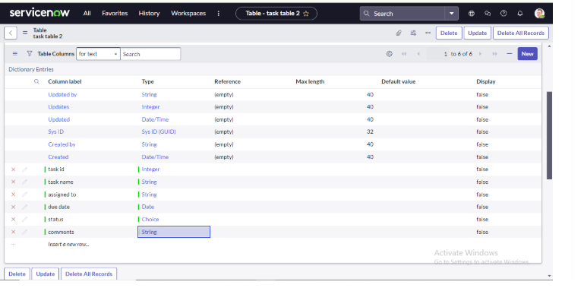

Milestone 5 : Assign users to groups

Activity 1: Assign users to project team group

1.Open service now.

2.Click on All  >> search for groups

3.Select tables under system definition

4.Select the project team group

5.Under group members

6.Click on edit

7.Select  alice p and bob p and save

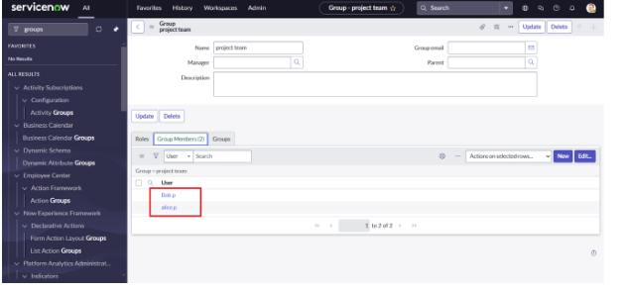

Milestone 6 : Assign roles to users

Activity 1: Assign roles to alice user

1.Open servicenow.Click on All  >> search for user

 2.Select tables under system definition

 3.Select the project manager user

4.Under project manager

5.Click on edit

6.Select project member and save

7.click on edit add u_project_table role and u_task_table role

8.click on save and  update the form.

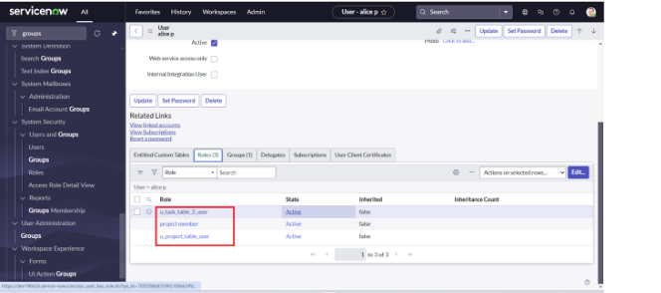

Activity 2: Assign roles to bob user

1,Open ServiceNow. Click on All  >> search for user

2.Select tables under system definition

3.Select the bob p user

4.Under team member

5.Click on edit

6.Select team member and give table role  and save

7. Click on profile icon Impersonate user to bob

8. We can see the task table2

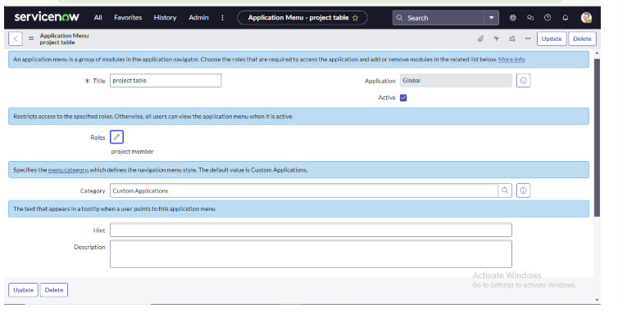

Milestone 7 : Application access

Activity 1: Assign table access to application

1. while creating a table it automatically create a application and module for that table

2.Go to application navigator search for search project table application

3.Click on edit module

4.Give project member  roles to that application

5.Search for task table2 and click on edit application.

6.Give the project member and team member role for task table 2 application

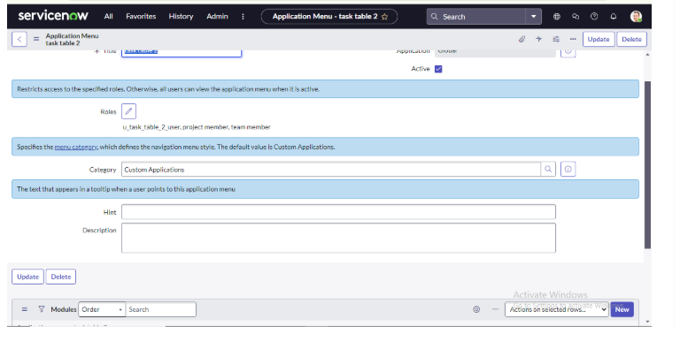

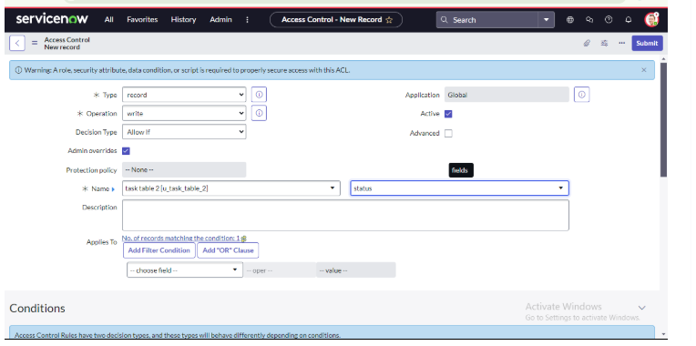

Milestone 8 :Access control list Activity 1: Create ACL

1.Open service now.

2.Click on All  >> search for ACL

3.Select Access Control(ACL) under system security

4.Click on elevate role

5.Click on new

6.Fill the following details to create a new ACL

Conclusion:

This project successfully streamlined user, group, and role management in ServiceNow. By automating access control, table creation, and workflow configuration, we improved efficiency, reduced manual work, and ensured secure role-based access. The system is now more organized, scalable, and user-friendly for IT service management.